NMPRK GUI User’s Guide

# Introduction

This application demonstrates the capabilities of the Node Manager Programmer’s Reference Kit (NMPRK) by providing the ability to choose an API function, view the signature, inputs and outputs for the function. In addition, it allows setting the input values and executing the functions on real Node Manager Systems and viewing the output values and request/response byte strings.

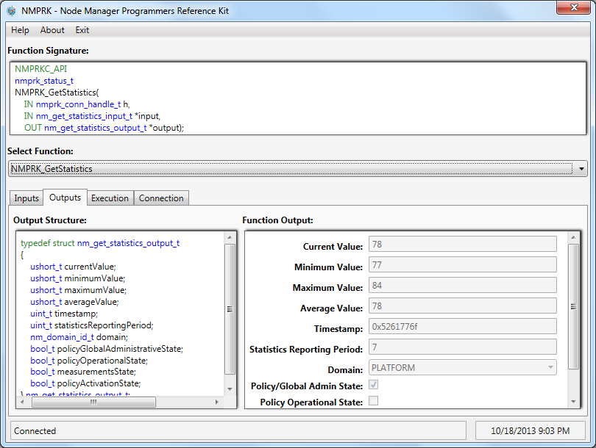

# Using the Application

## Connection Tab

This tab allows the user to connect to the BMC of the local server or remote server. Connection to the local server can be done through one of the following IPMI drivers: Microsoft Generic IPMI Device or Intel IMB Driver (the application will use the first one it finds that is enabled). Connection to a remote server requires an IP address, username and password. When the user clicks ‘Connect’, the application attempts to connect and searches for the Node Manager SDR that indicates the bridging information. If this SDR is not available, the user may use the ‘Manually Enter Bridging Information’ box. Connection is not required to view function signature and parameters, but in order to execute any functions, the user must be connected.

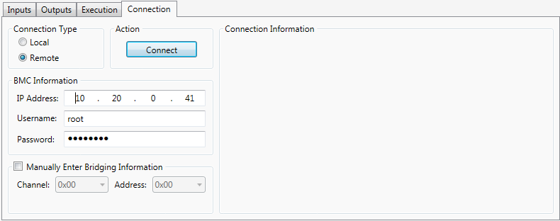

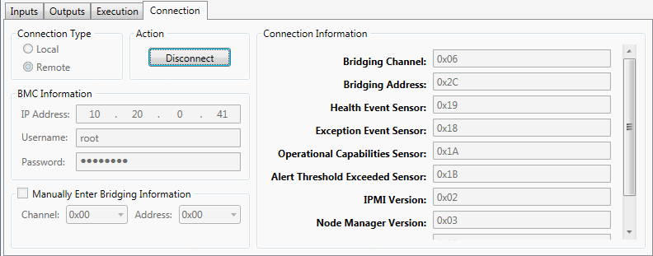

## Select Function

Users select from a list of functions available in the API using the Select Function combo box in the middle portion of the window. Once a function is selected, the user can see the function signature at the top of the screen and can view the inputs and outputs of the function in more detail using the Inputs and Outputs tabs on the bottom portion of the screen.

## Inputs Tab

This tab allows the user to view the input parameters for the function. It also allows the user to modify the values of each input parameter that will be used if the function is executed using the Execution tab.

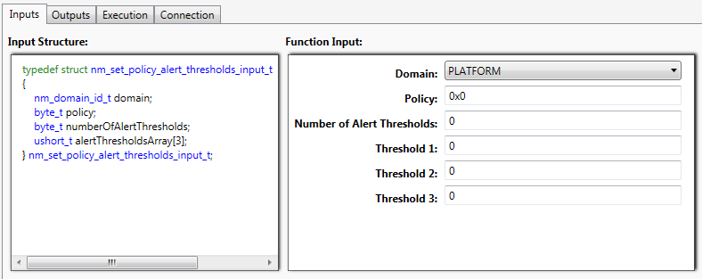

## Outputs Tab

The tab allows the user to view the output parameters for the selected function. After a function has been executed, it will also display the value for each output parameter.

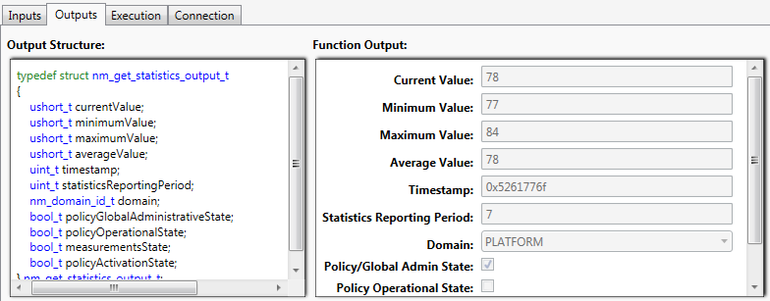

## Execution Tab

This is where the user goes to execute the selected function. If the application is not connected to a server, the ‘Invoke Function’ button will be disabled. After executing a function, the Outputs tab is populated as well as the Request Bytes and Response Bytes field on this tab.

**Note**: The byte strings are displayed in the same manner as they would be in IPMITool. They do not reflect the all bytes being transmitted or received for a particular command. On the request side, the first byte is the Net Function and the second byte is the Command. All subsequent bytes are the command data. On the response side, the first byte is the completion code and all subsequent bytes are command data.

